**Session 2 : HDFS**

**Assignment 2.2**

**Task 3:**

**Create a file max-temp.txt in local FS.**

**Put some 10-15 records of date and temperature example:**

**dd-mm-yyyy,temperature**

**Example:**

**10-01-1990,10**

**10-02-1991,20**

**Move this file to HDFS at /user/acadgild/hadoop.**

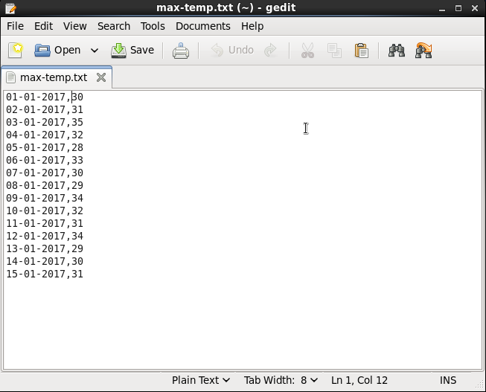

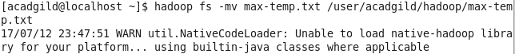

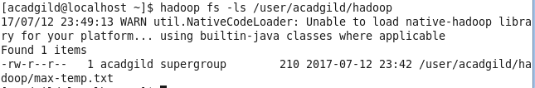

**Task 4:**

**Change the permission of the file /user/acadgild/hadoop/max-temp.txt, such that**

**only the owner and the group members have full control over the file.**

**Others do not have any control over it.**

